Problem identification: questions to the experts

- Context: Problem Identification
Problem identification is the first step of an impact assessment. The outcome of the problem identification will be a clear scope of the framework guideline. Answering the problem identification requirements ensures that further texts (FG, NC) match comitology requirements.

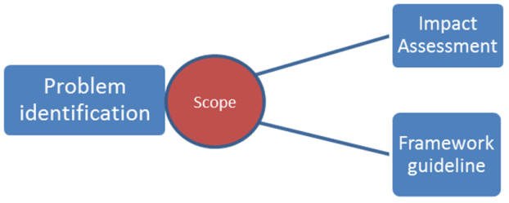

Problem identification should:
- describe the nature of problem in clear terms and support the description with clear evidence ;
- set out clearly the scale of the problem ;
- set out clearly who is most affected by it ;
- identify clearly the drivers or underlying causes of the problem ;
- describe how the problem has developed over time and how existing policies at Community or Member State level affect it ;
- identify a clear baseline, i.e. describe how the problem is likely to develop in the future without new EU action ;
- identify clearly assumptions made, risks and uncertainty involved.

Clear evidence of the problem raised is the first step of the analysis, necessary to proceed any further. The objective of this series of questions is to gather this evidence.
Thus, any answer to the following questions should be based on specific and concrete evidence, illustrated to the extent possible with numbers and figures.

- Nomination

Problem
The task force identified that the lack of harmonisation related to nomination constitutes an obstacle to the efficient functioning of the market. In particular, various nomination/re-nomination/confirmation deadlines could be an obstacle to the development of short-term trading and short-term capacity allocation, thus potentially affecting both shippers and operators.
- Do you share this analysis? Please provide justification.
- Can you provide a specific example of a problem resulting from a lack of harmonisation in the Nomination/Re-nomination/Confirmation procedures? What aspects of nomination regimes need to be harmonised - for example, in your view, do differences in timing of day-ahead entry/exit nominations, time window for re-nominations, minimum re-nomination lead-times, confirmation timing present a problem? What are the potential problems that may arise due to the co-existence of daily and hourly nomination schedules?
- Based on your experience, do you view these problems as local, regional or European?

Policy options
Based on the analysis conducted by the task force, the following options are being discussed:
- OPTION 1: No further harmonisation
- OPTION 2: implement new/modified EU rules
EASEE-gas developed CBP 2003-002-01, a voluntary standard for harmonisation of the nomination procedures. The 2010 issue of ERGEG monitoring report showed that 47.5% of respondents from TSOs stated that EASEE-Gas is being used as the nomination procedure at the respective IP.
- Do you think that the EASEEgas CBP on nominations already provides for a valid solution to the problems identified?
- If not, what are the flaws of the current EASEEgas rules and can you think of an acceptable alternative solution?
Harmonisation could be limited to interconnection points, or include connection points to adjacent operators.
- Do you see any potential conflict that may arise with adjacent operators if harmonised nomination rules are to be implemented by TSOs at points connecting their systems to adjacent ones(meaning: two different nomination regimes for entry and exit at one point)? If so, in which way should one harmonise, including these points, to avoid these conflicts?

- Interconnection Agreements
Problem
No evidence of a concrete problem solely linked to an interconnection agreement has been gathered so far. However, difficulties to reach bilateral agreements have been reported, and the lack of implementation reported by the EASEEgas CBPs can be understood as an indirect evidence of these difficulties, and the need for improvement of TSO cooperation. Although interconnection agreements are established between TSOs, they affect shippers.
- Do you share this analysis?
- Can you provide a specific example of a problem resulting from a) the none existence of an interconnection agreement and b) a lack of harmonisation regarding such an agreement?
- Based on your experience, do you view this problem as local, regional or European?

Policy option
Based on the analysis conducted by the task force, the following options are being discussed
- OPTION 1: No further harmonisation
- OPTION 2: implement new/modified EU rules: TSO cooperation
  - OPTION 2.a - case by case resolution: no specific guidance, but in case no bilateral or regional agreement (regional resolution of issues within the GRIs) is reached and regulators cannot solve the issue, the case goes to ACER;
  - OPTION 2.b - harmonisation of the format of the interconnection agreement, specifying a template or a list of issues to be tackled as a minimum, on which to base a case by case approach;
  - OPTION 2.c - harmonisation of the format and content of the interconnection agreement, specifying a list of issues to be tackled, as well as detailed default rules when no agreement is reached.

- Do you see other options? Which option do you favour? Please provide justification.

A possible list of issues the network code could require TSOs to tackle in their interconnection agreements could be:
- Business Rules
  - Shipper’ registration
  - Matching rules and Scheduling Process (programming and matching purposes)
  - Flow Control/Imbalance handling
  - Exception notices (in case of deficient gas quality)
  - Allocation regime (e.g. OBA, Pro-rata, BSA) and the communication of the allocation data (shipper detail).
- Technical Rules
  - Maintenance
  - Energy and Quality Measurement
  - Right of Access
  - Exceptional flow conditions in circumstances which might cause capacity reductions
  - Delivery conditions
    - Gas pressure
    - Gas temperature
    - Gas quality
  - Energy conversion
- Data exchange: Communication and Online Data Transmission
- Duration (when the Interconnection Agreement becomes effective and until when it shall remain in force)
- Confidentiality
- Liability and Circumstances Excluding Liability
- Governing Law and Dispute Resolution
- Amendment of the IA
- Relation to other agreements
- Force Majeure
- Do you agree with the content of this list?
- Are there additional issues that you would include and others you would exclude?
- Can you relate your answer to any practical problem that you faced?
- Apart from a minimum list of items to be tackled, would you like the FG to set out guidance on additional issues (rules on revisions of IAs etc.) ?

- Capacity calculation
According to article 16 R715/200), the maximum capacity at all relevant points […] shall be made available, taking into account system integrity and efficient network operation.

A. Physical capacity calculation
D .Maximum Capacity
B. System integrity
C .Efficient Network Operation
The Task Force defined the maximum capacity as the difference between physical capacity calculated and the sum of the capacities required for system integrity and efficient network operation.
- To your knowledge, is there a direct relation between physical and commercial capacity? Is it possible to optimise the physical capacity calculated by TSOs? Please provide justification.

Problem
The analysis conducted by the task force shows that the current legal framework requires improvement in order to ensure the required levels of Transparency and TSO Cooperation to ensure that maximum capacity is made available at interconnection points.
The Task Force excluded issues related to system integrity as out of the scope of the current guideline.
- Do you share this analysis?
- Can you provide a specific example of a problem resulting from a lack of harmonisation in the physical capacity calculation, network operation procedures, scenarios used or frequency of capacity recalculation?
- Are the problems you identified in your view linked to a lack of transparency and/or TSO cooperation or do you see any other underlying problems?
- Based on your experience, do you view this problem as local, regional or European?

Policy options
Based on the analysis conducted by the task force, the following options are being discussed
- OPTION 1: no further harmonisation
- OPTION 2: Transparency – harmonisation on the publication (format, content and periodicity) of maximum capacity at each side of the border, input parameters related to capacity calculation and extreme scenarios.
- OPTION 3: Transparency, update and cooperation – Transparency requirements include harmonisation on the publication (format, content and periodicity) of maximum capacity at each side of the border, input parameters related to capacity calculation and extreme scenarios. Cooperation requirements include the necessity for TSOs to work on maximum capacity discrepancies at each side of the border. A case-by-case approach will apply. If no bilateral agreement is reached and regulators cannot solve the issue, the case goes to ACER.

- Do you see other options? Which option do you favour? Please provide justification.
Possible identified input parameters as referred to in option 3 could be:
  - temperature
  - pressure, compression power
  - elevation
  - gas compressibility
  - gas density
  - friction factor, roughness of the pipe, viscosity of the gas

- Do you agree with the content of this list? Are there parameters that you would include or exclude?
- Can you relate your answer to any practical problem that you faced?
- Which would be a relevant periodicity for providing an update on physical capacity calculation parameters and extreme operating scenarios?

- Gas Quality

Problem
From the ENTSOG Transparency platform, on a range of IPs, it is clear that differences in gas quality specifications at either side of an IP exist. Nowadays, these differences are being treated on a reasonable endeavour basis by the TSOs on either side of the IP or even across each other systems by swapping, co-mingling or blending the gas within their individual systems. The analysis of the TF shows that although differences in gas quality and their handling might become a European issue, it remains a local or regional issue at the moment. It shows that the resolution of these local or regional issues depends on the success of TSO cooperation.
- Do you share this analysis?
- Based on your experience, do you view this problem as local, regional or European?
- Can you provide a specific example of a problem resulting from a lack of alignment of gas quality specifications or regarding the management of differences in gas quality at the level of shipping?

Policy Option
Based on the analysis conducted by the task force, the following options are being discussed
- OPTION 1: No further EU action;
- OPTION 2: TSO cooperation on handling differences in gas quality & Case by case approach with intervention by regulators and ACER where bilateral problems due to gas quality cannot be solved by TSOs in a way that ensures proper functioning of the market and unhampered trade;
- OPTION 3: TSO cooperation and default rule on sharing costs and responsibilities for measures related to the management of gas quality differences (i.e. the EASEE-gas CBP approach or a cost-benefit analysis approach where costs of swapping, co-mingling or blending in the systems concerned are compared).

- Do you see other options? Which option do you favour? Please provide justification.

- Odorisation

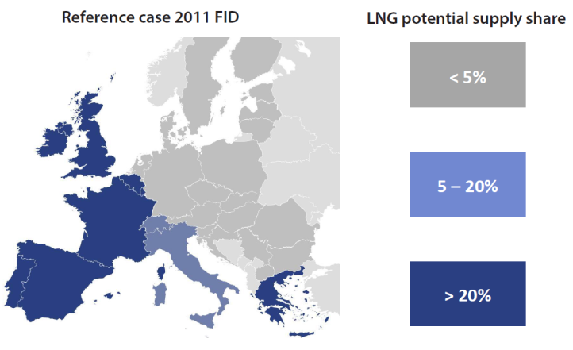
Problem
In its 2010 version of the TYNDP, ENTSOG identified the impossibility of flows from France to Belgium or Germany as a barrier to market integration, as this bottleneck hampers the flows from the South-West region to the rest of Europe.
The analysis of the Task Force shows that the odorisation problem is local (French-Belgian and French-German IPs) but has trans-regional consequences (South-West & North-North West market integration).
- Do you share this analysis?
- Can you provide other specific examples of a problem resulting from a lack of harmonisation in odorisation practices?
- Do you view this problem as local, regional or European?

Policy options
Based on the analysis conducted by the task force, the following options are being discussed
- OPTION 1: No harmonisation;
- OPTION 2: case by case resolution: no specific guidance, but in case no bilateral or regional agreement (regional resolution of issues within the GRIs) is reached and regulators cannot solve the issue, the case goes to ACER;
- OPTION 3: Harmonisation rule: odorisation practices shouldn’t hamper cross-border flows.

- Do you see other options? Which option do you favour? Please provide justification.

- Units Harmonisation

Problems

The examples and analysis conducted by the TF show market integration issues, specifically consisting in barriers to trade and inefficient functioning of the market, as various unit references add complexity and costs to the daily activity of network users.

- Do you share this analysis?
- Can you provide other specific examples of a problem resulting from a lack of harmonisation in odorisation practices?
- Do you view this problem as local, regional or European?

Policy options
Based on the analysis conducted by the task force, the following options are being discussed
- OPTION 1: No Harmonisation;
- OPTION 2: Harmonisation, completing the existing regulation, of all units used in the communication between shippers and TSO regarding energy, volume and gross calorific value.

- Do you see other options? Which option do you favour? Please provide justification.
There is a good level of harmonisation based on EASEEgas standard in most European countries.
- Do you think that EASEEgas already provides for a valid solution? If not, what are the flaws and can you think of an acceptable alternative solution?

- Data Exchange
Problem
The task force identified barrier to trade and discrimination, as various data formats add IT costs to the daily activity of network users and the entry cost might penalise small shippers more than incumbents.
- Do you share this analysis?
- Can you provide a specific example of a problem resulting from a lack of harmonisation regarding data exchange?
- Based on your experience, do you view this problem as local, regional or European?

Policy option
Note: the legal feasibility of the following options has to be further assessed. For the sake of discussion, all of them are assumed to be legally valid options.
- OPTION 1: no harmonisation;
- OPTION 2: guidance – handbook on a voluntary basis;
- OPTION 3: harmonisation with binding rules.

- Do you see other options? Which option do you favour? Please provide justification.
Possible identified topics to be included in a handbook could be:
  - Data exchange protocol and format (with reference to EDIG@S)
  - Confidentiality & Security
  - Implementation guidelines
  - Development of new technical solutions
  - Core content of the messages

- Do you agree with the content of this list? Are there topics that you would include or exclude?
- Can you relate your answer to any practical problem that you faced?

http://easee-gas.eu/docs/cbp/approved/EASEE-gasCBP2003-002-01Rev3.doc
Ref: E10-GMM-11-05 of 2 February 2011 - http://www.energy-regulators.eu/portal/page/portal/EER_HOME/EER_PUBLICATIONS/CEER_PAPERS/Gas/Tab/E10-GMM-11-05_CAM-CMP%20Monitoring%20Report_2-Febr-2011.pdf
See the 2010 Review of the Implementation progress of the EASEE-gas Common Business Practices - http://easee-gas.eu/media/6229/cbp_implementation_report_final.pdf
Configuration of the network and input parameters

